The Zones of Regulation

A Guide for Parents

What is The Zones of Regulation?

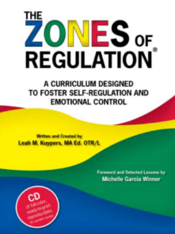
The Zones of Regulation is an internationally renowned intervention which helps children to manage difficult emotions. Our goal is to equip all children with coping and regulation strategies so they can manage anxiety, stress, and challenging situations more effectively.
From time to time, all of us (including adults) find it hard to manage strong feelings such as worry, anger, restlessness, fear or tiredness, and this stops us from getting on with our day effectively. Children who feel these emotions often find it hard to learn and concentrate in school. The Zones of Regulation aims to teach children strategies to help them cope with these feelings so they can get back to feeling calm and ready to learn.
By learning how to cope with these feelings, children can develop resilience, tackle challenges more confidently, and avoid giving up when things get difficult. Teaching these skills from a young age helps children better manage the transition to secondary school and thrive, reducing the likelihood of developing negative coping strategies that affect mental or physical wellbeing.

The Zones

- Blue Zone – Low level of alertness; not ready to learn; may feel sad, tired, bored, or moving slowly.
- Green Zone – Calm and alert; optimal for learning; feels happy, calm, focused, or okay.
- Yellow Zone – Heightened alertness with some control; may feel frustrated, worried, silly, excited, or a little out of control.
- Red Zone – Intense emotions and high alertness; not ready to learn; out of control; may feel angry, terrified, or extremely upset. This sometimes affects rational thinking.
It is important to note that all Zones are normal and no Zone is “bad” or “naughty.” For example, the Blue Zone is useful when falling asleep.

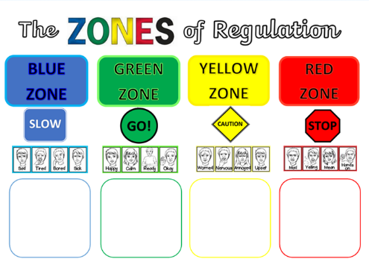

What will you be teaching my child?

Through the Zones of Regulation, we aim to help children:
- Recognise when they are in different Zones and learn how to change or stay in a Zone
- Increase their emotional vocabulary to describe how they are feeling
- Recognise when others are in different Zones and develop empathy
- Understand what might make them move into different Zones
- Recognise that emotions, sensory experiences (such as lack of sleep or hunger), and the environment can influence which Zone they are in
- Develop problem-solving skills and resilience
- Identify strategies they can use, forming a toolkit personalised to them that can be used when they face everyday challenges.

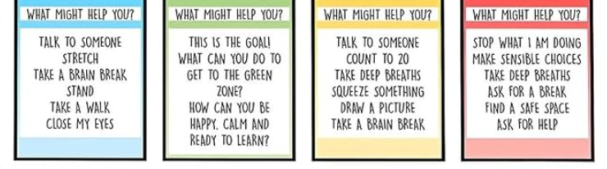

How will my child learn about the zones?
- Children will learn the Zones through dedicated assemblies and lessons.
- Zones language will also be used throughout the school day by all staff, not just the class teacher.
- Some children may have small group or individual sessions to further support their understanding.
- Sometimes children may prefer to label emotions directly rather than using Zone names, and this is encouraged.

How can I help with The Zones at home?
Parents can support their child’s learning in the following ways:
- Name your own feelings using Zones language (e.g., “I’m frustrated; I think I’m in the Yellow Zone.”)
- Talk about which tools you will use to return to the Green Zone (e.g., “I’m taking four deep breaths to help calm down.”)
- Discuss which Zone your child or a character in a book or film might be in (e.g., “You look sleepy; are you in the Blue Zone?”)
- Avoid discussing Zones when a child is in the Red Zone; wait until they are calm
- Teach your child which tools they can use (e.g., reading together in a comfy chair to move to the Blue Zone)
- Regularly check in: “How are you feeling now?” and “How can you get back to Green?”
- Model using tools yourself and explain it to your child
- Share how their behaviour affects your own Zone (e.g., “Your calmness helps me feel happy too.”)
- Display Zones visuals and tools at home
- Praise and encourage your child when they identify their Zone

Tips for Practicing the Zones
- Understand your own reactions before addressing your child’s behaviour
- Be aware of triggers (e.g. what happens to before your child go into a zone)
- Be consistent in managing behaviour and using the same language at home
- Empathise and validate feelings (e.g. it’s OK to feel …)
- Keep clear boundaries and routines, and always follow through
- Don’t address a child who is angry or upset until you are calm
- Discuss strategies for next time and encourage empathy by asking how their choices made you feel
- Praise your child for using strategies, and encourage sensory breaks to help regulate their bodies
- Create a tool box with items to help your child self-regulate when they are in each zone

Common Questions
Can my child be in more than one Zone at the same time?
Yes. A child might feel tired (Blue Zone) because of lack of sleep and anxious (Yellow Zone) about a school activity. Identifying multiple Zones shows good awareness of feelings.
Should children be punished for being in the Red Zone?
It’s best to let children experience natural consequences. For example, if they hurt someone or damage property, they should repair the situation and reflect on what they could do differently next time.
Can children appear to be in one Zone but feel another inside?
Yes. Children may “mask” their Zone to meet social expectations at school. They may only express their Red Zone emotions at home, where they feel safe.

