
Calverley Parkside Primary | Topic: Uses of Everyday Materials | Strand: Physics

We will be able to:
Key Word | Meaning
1. Material | The matter from which a thing is or can be made.
2. Absorbent | Able to soak up another substance or liquid.
3. Waterproof | Able to resist water.
4. Stretch | Making something longer or wider without it tearing or breaking
5. Transparent | Allowing light to pass through so it can be seen.
6.Opaque | Not allowing light to pass through. Not transparent.
7. Properties | The qualities of an object or material; what it can do.
8. Rigid | Unable to bend.

- Identify and compare the suitability of a variety of everyday materials, including wood, metal, plastic, glass, brick, rock, paper and cardboard for different uses.
- Find out how the shapes of solid objects made from some materials can be changed by squashing, bending, twisting and stretching.

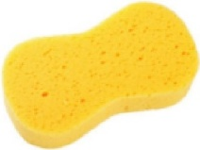
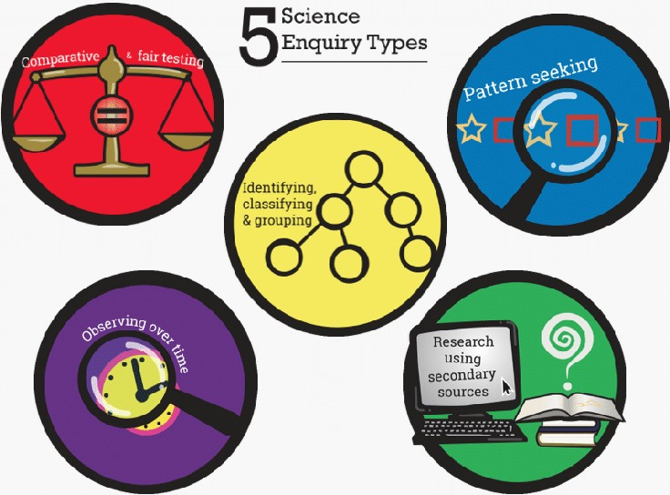
- Materials have a number of different properties.

durable

absorbent

stretchy
Key questions!
What material is best for this job?
Can you find a material that is hard/soft/flexible/rigid?

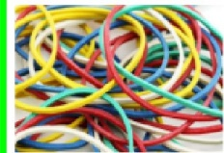

flexible
- Distinguish between an object and the material
from which it is made

- Identify and name a variety of everyday materials, including wood, plastic, glass, metal, water, and rock
- Describe the simple physical properties of a variety of everyday materials
- Compare and group together a variety of everyday materials on the basis of their simple physical properties.
What I should already know:

waterproof


strong

