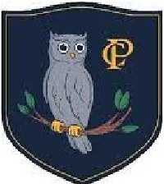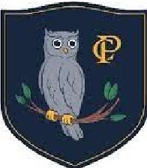
Calverley Parkside Primary | Topic: Animals including humans | Strand: Biology

We will be able to:
Key Word | Meaning
1. Life Cycle | The changes things go through to become an adult
2. Adult | A fully-grown animal or plant
3. Grow | Undergoing natural development to increase in size.
4. Young | Offspring which has not reached adulthood
5. Survive | To continue to live
6.Hygiene | How we keep ourselves clean
7. Exercise | The physical activity to keep our body fit
8. Diet | The food or water that an animal needs

- Notice that animals, including humans, have offspring which grow into adults
- Find out about and describe the basic needs of animals, including humans,
for survival (food, water, air)
- Describe the importance for humans of exercise, eating the right amounts of
different types of food, and hygiene

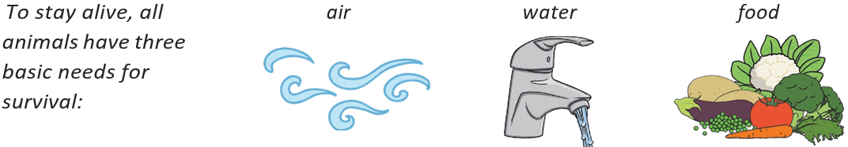
- Identify and name a variety of common animals that are carnivores, herbivores and omnivores
- Identify, name, draw and label the basic parts of the human body and say which part of the body is associated with each sense

What I should already know:


